Practical - 6
Practical Title: Rendering External JSON Data using Fetch API, Search and Filter
Problem Definition: Display event lists, student profiles, notices, or FAQs from external JSON
files using Fetch API. Implement dynamic rendering, search, filter, sorting, and pagination.
Theory:
- How is JSON fetched, parsed, and rendered?
Ans: It is fetched from the local path using the fetch() API, parsed automatically into JavaScript objects using .then(response => response.json()), and rendered by generating HTML string templates with .map() and injecting them into the #output container using .innerHTML.

- Which array methods are used for search, filter, sort, and pagination?
Ans:
Search & Filter: filter() combined with string methods like toLowerCase() and includes().
Sort: sort() using localeCompare().
Pagination: slice() to extract 5 items per page based on the current page index.

- How are loading and error states handled?
Ans: Error states are handled using a .catch() block that writes "Error loading JSON" into the output area if the fetch request fails, while loading states are handled implicitly because the display function only executes after the promise resolves.

- How is modularity maintained in JavaScript files?
Ans: Modularity is maintained by keeping separate, dedicated JavaScript files for each feature/page (e.g., events.js, students.js, notices.js, faqs.js) and breaking the code into small, single-purpose functions like display(), sortData(), next(), and previous().

Implementation/ Output/Result :
Events:
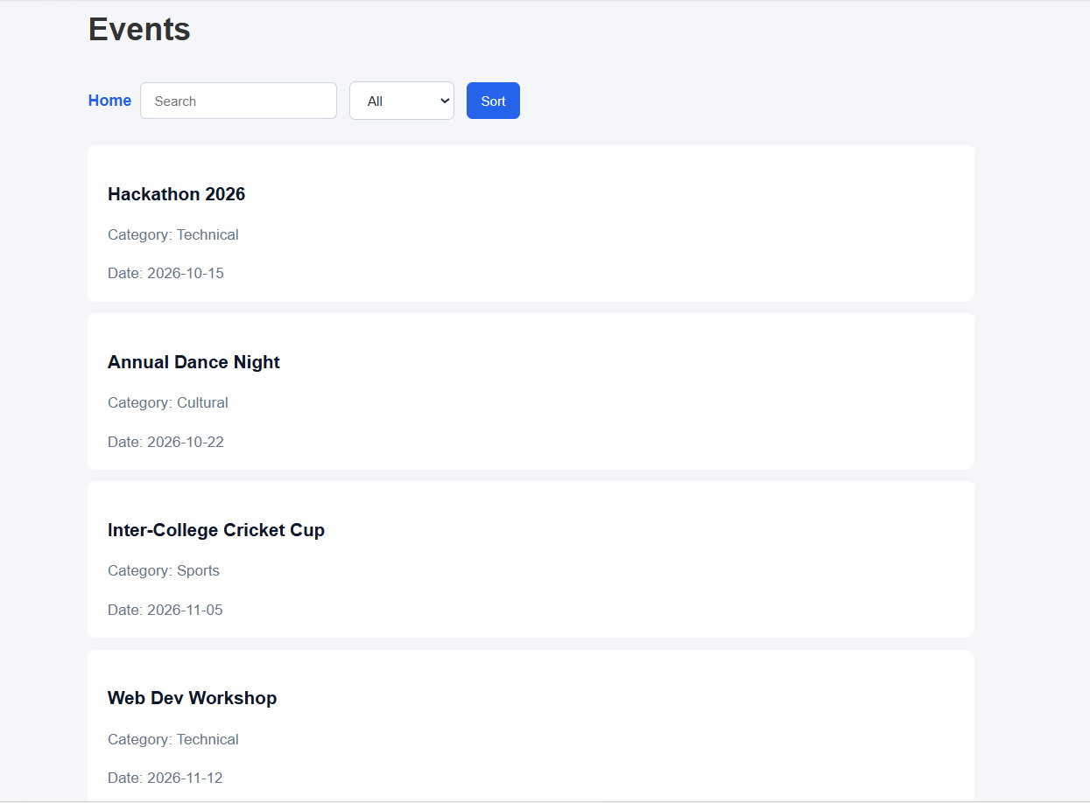
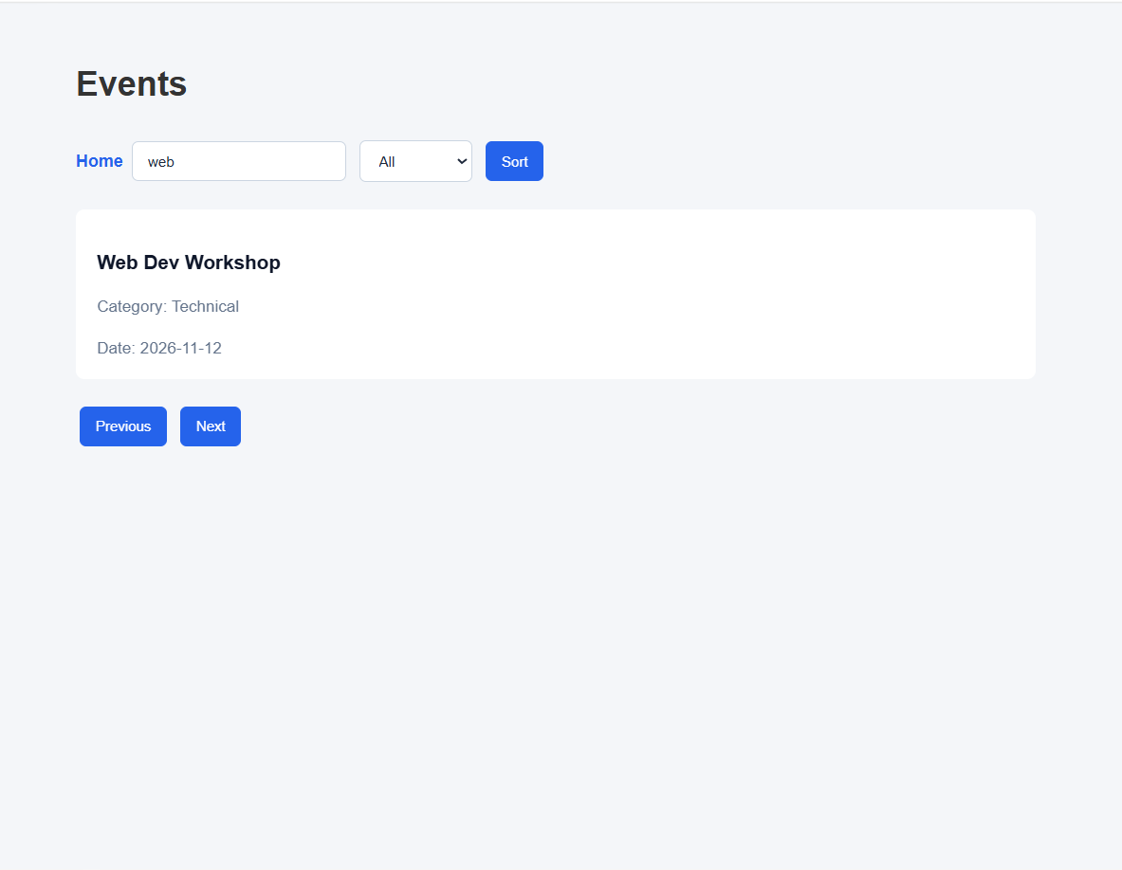

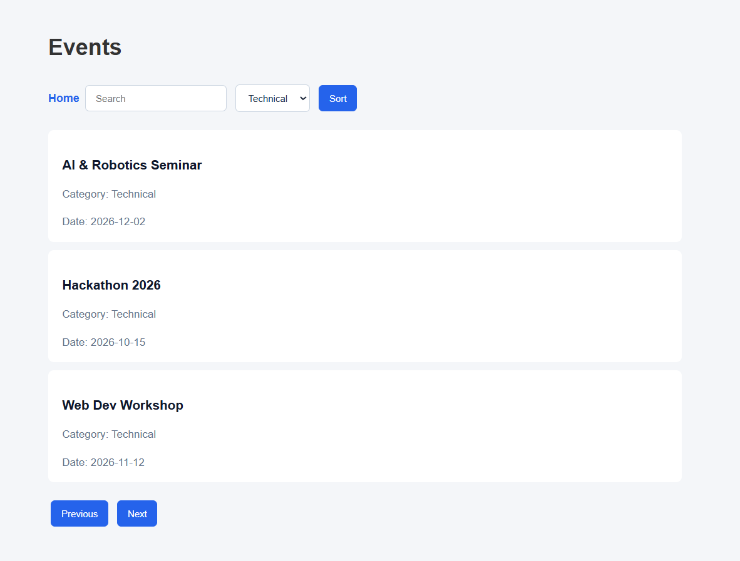

Students:
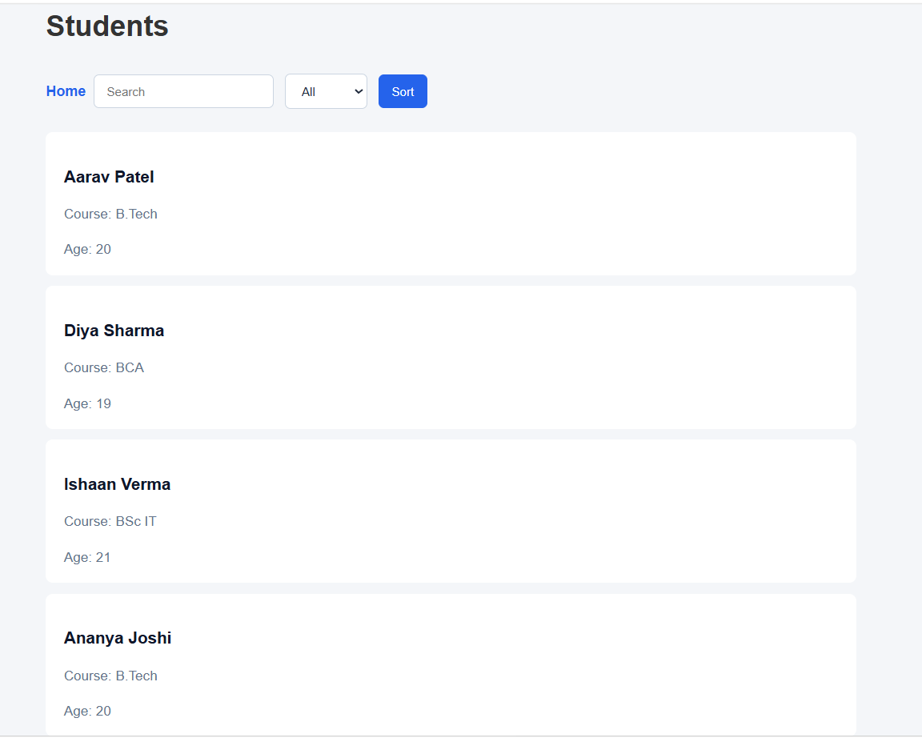

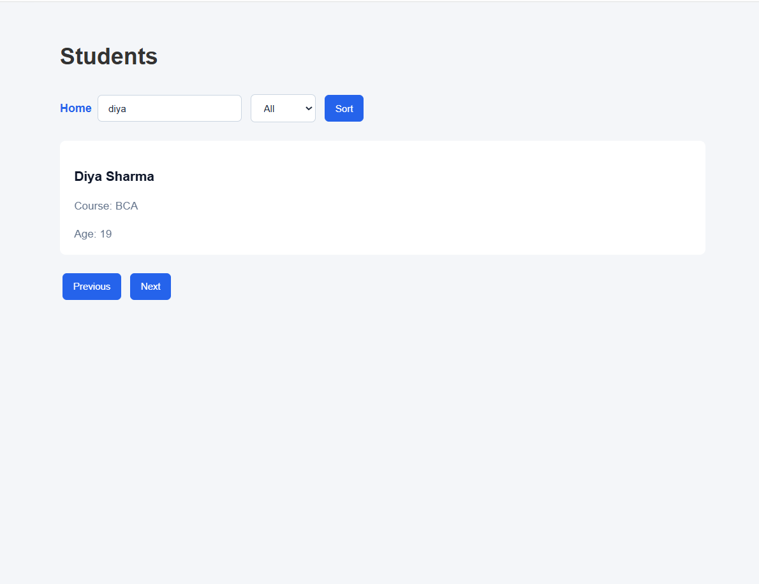
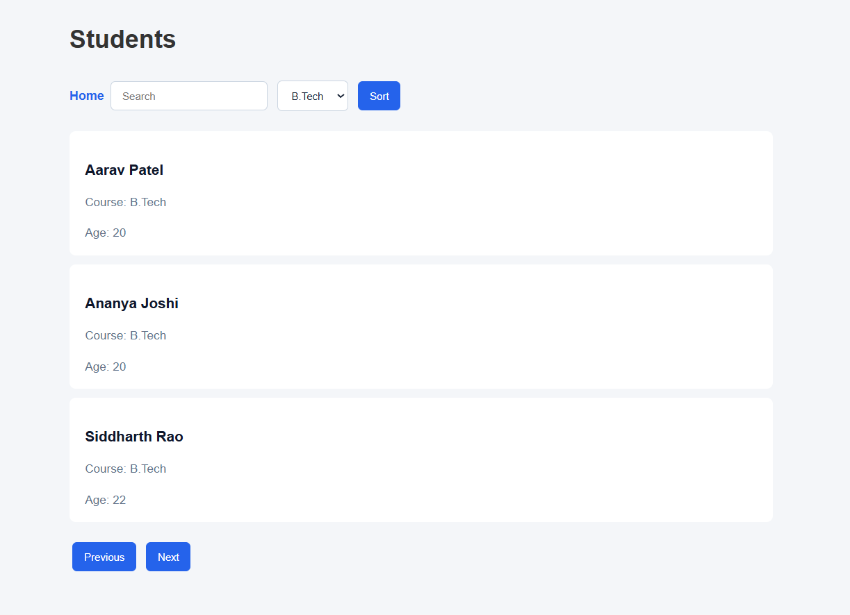

Notics:
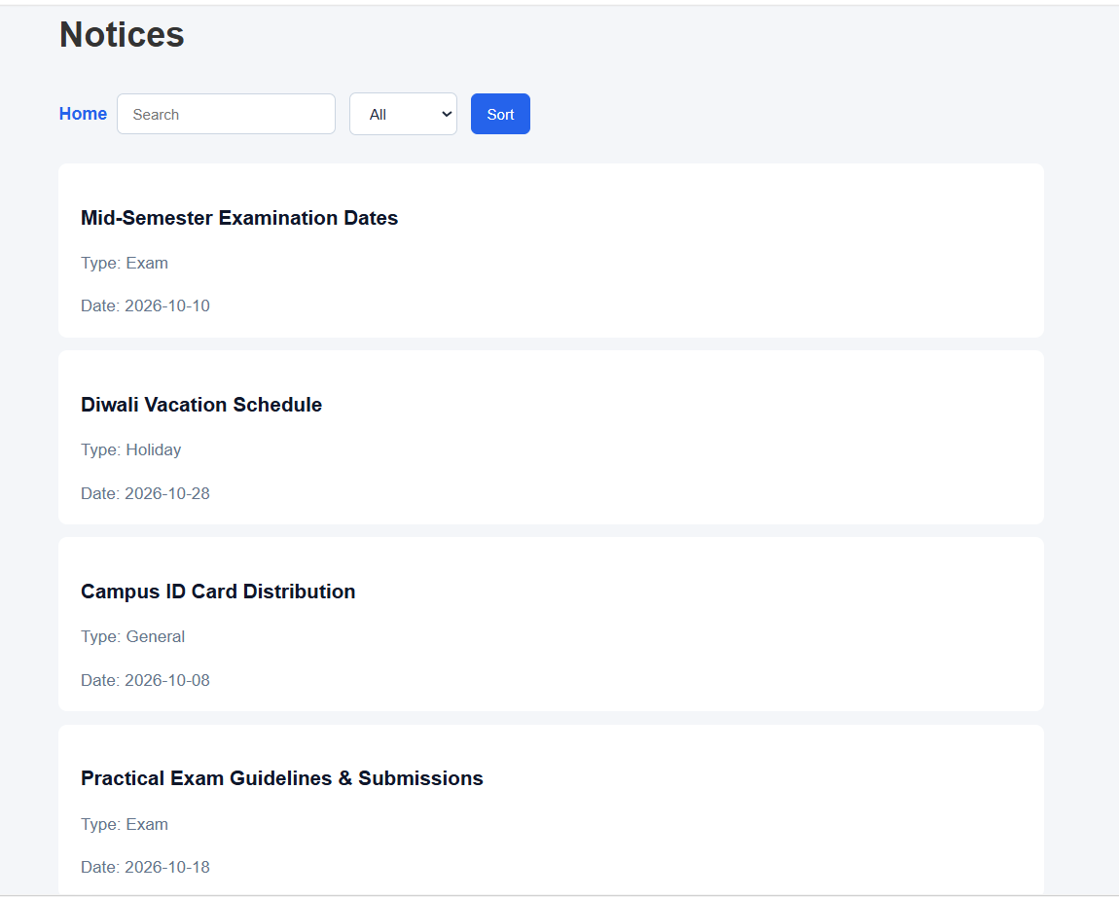
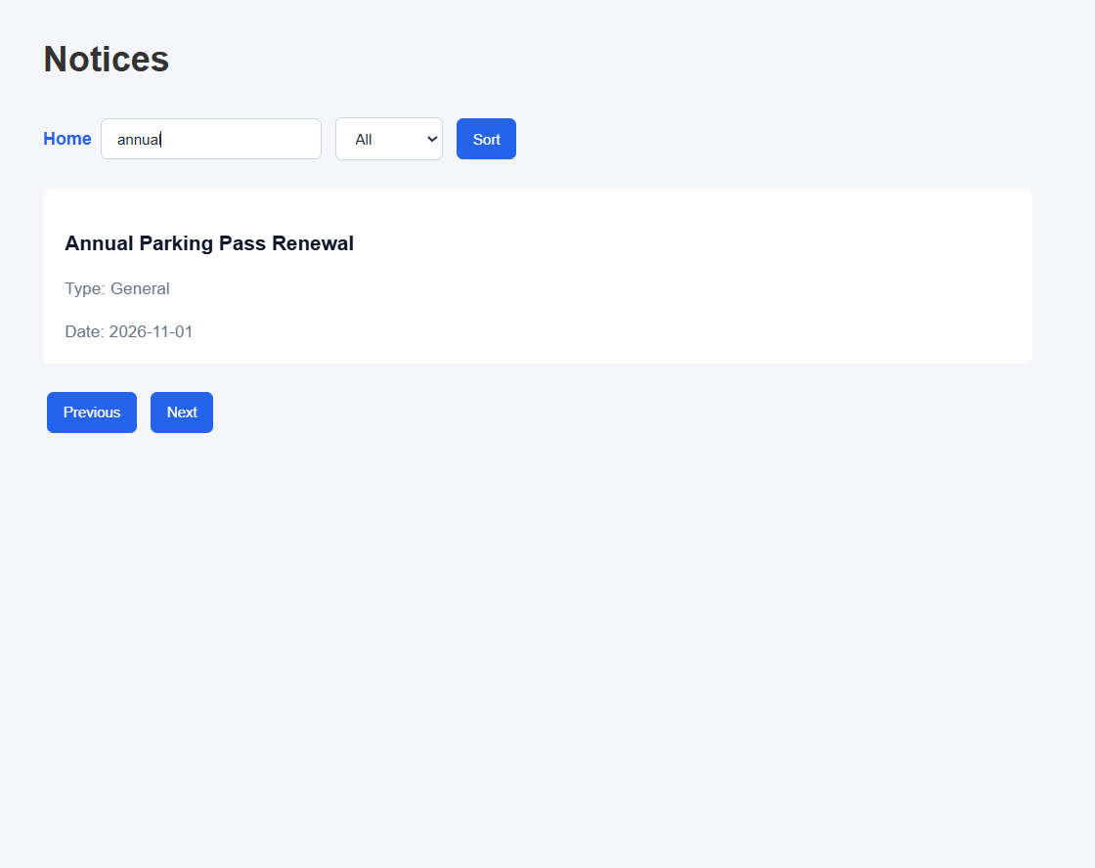

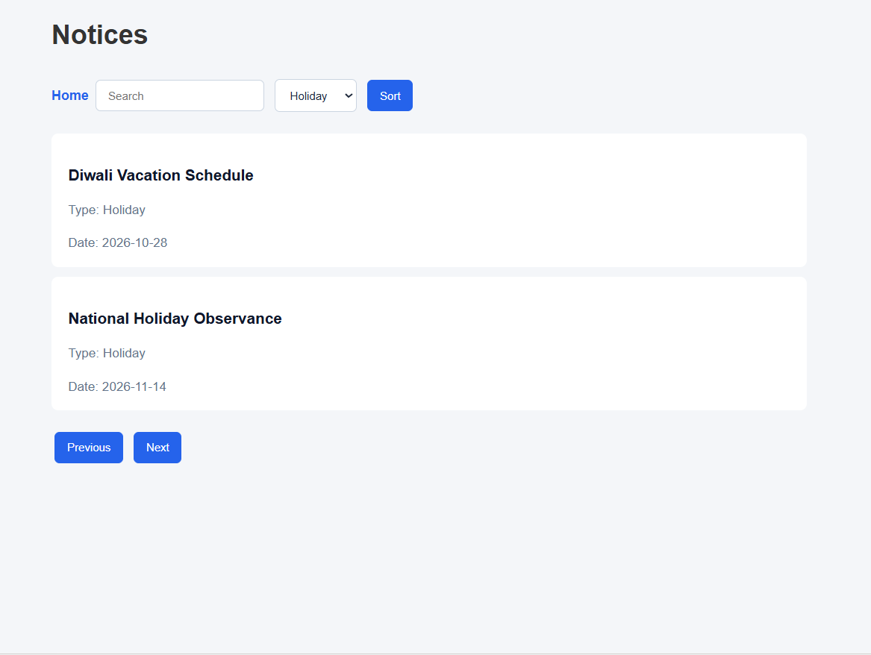

FAQs:
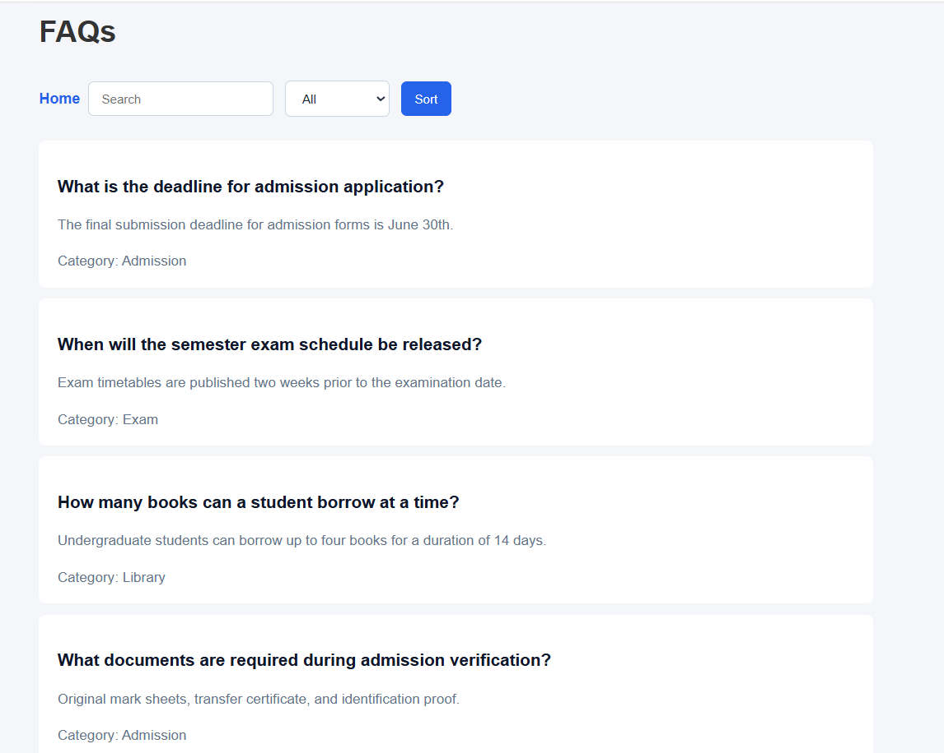

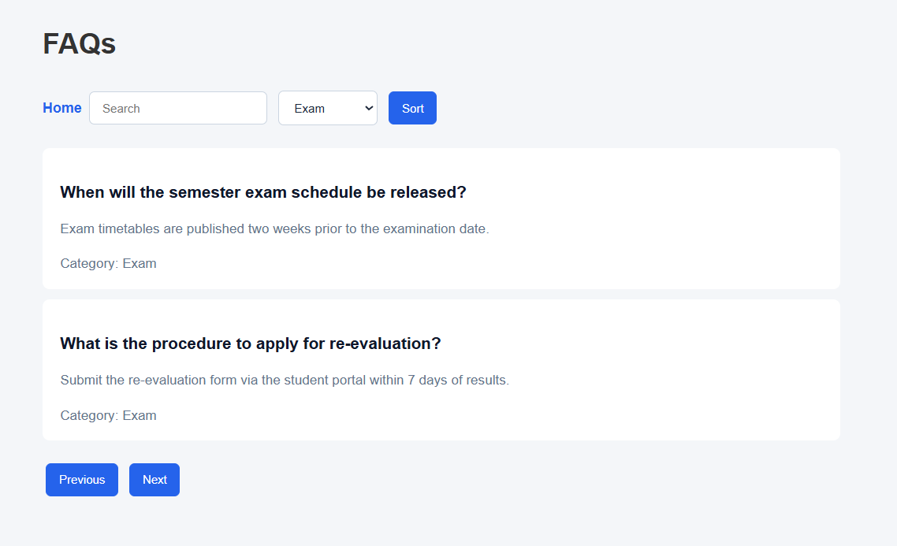

- GitHub Repository Link:
StudentHub/JSON/practical6 at main · savaliyariya03/StudentHub
- Challenges Faced:
Handling asynchronous data timing so UI elements render only after fetch() completes, and keeping search, category filter, and page slice calculations synced without losing the original dataset.
- Learning Outcomes:
Learned how to consume and parse external JSON data using the JavaScript fetch() API, and mastered practical array methods (filter, sort, slice, map) to build interactive search and pagination.
- Faculty Remarks:

